20250213 DateTime

## Aufgabe 1

1.1 Why are LocalDate, LocalTime, and LocalDateTime immutable in Java, and what are the benefits of this design?

1.2 What is the difference between ISO_LOCAL_DATE, ISO_LOCAL_TIME, and ISO_LOCAL_DATE_TIME in DateTimeFormatter? Provide examples of each format.

1.3 What happens if you add one month to LocalDate.of(2024, 1, 31)? Will the result be 2024-02-31? Why or why not?

1.4 How do you format a LocalDateTime into the pattern "dd/MM/yyyy HH:mm" using DateTimeFormatter?

## Aufgabe 2

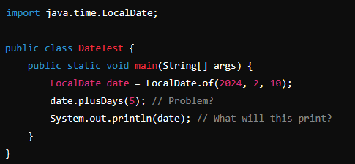

**2.1 What will be the output of the following code?**

A) 2024-02-15

B) 2024-02-10

C) Compilation error

D) Runtime exception

Answer:

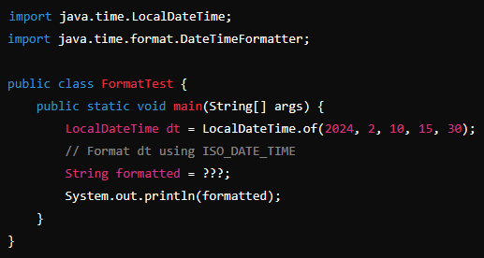

**2.2 What should replace ????**

A) dt.format(DateTimeFormatter.ISO_DATE)

B) dt.format(DateTimeFormatter.ISO_LOCAL_DATE_TIME)

C) DateTimeFormatter.ISO_DATE_TIME.format(dt)

D) Both B and C

Answer:

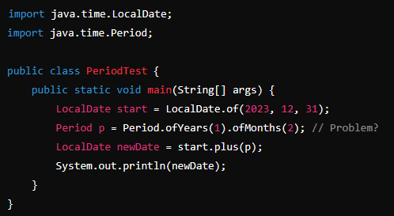

**2.3 What will be printed by the following code?**

A) 2025-02-28

B) 2024-02-28

C) 2024-02-31

D) 2024-02-29

Answer:

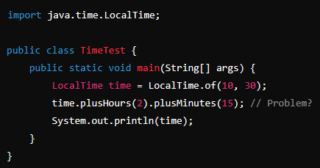

**2.4 What happens when executing this code?**

A) 12:45

B) 10:30

C) Compilation error

D) Runtime exception

Answer:

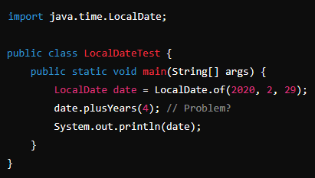

**2.5 What will be printed by the following code?**

A) 2024-02-29

B) 2020-02-29

C) Compilation error

D) 2024-03-01

Answer:

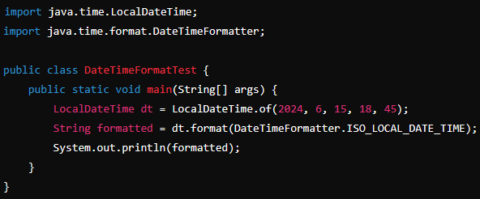

**2.6 What is the output of the following code?**

A) 2024-06-15 18:45

B) 15-06-2024T18:45

C) 2024-06-15T18:45:00

D) Compilation error

Answer:

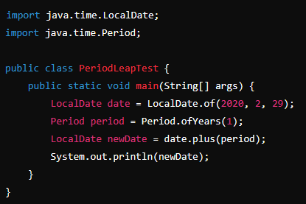

**2.7 What happens when executing this code?**

A) 2021-02-28

B) 2021-02-29

C) 2021-03-01

D) Compilation error

Answer:

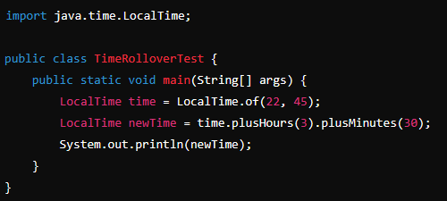

**2.8 What will be the output of the following code?**

A) 02:15

B) 01:15

C) 00:15

D) 03:15

Answer: